### 

PROJECT BY - AAYUSH JAIN

### **Forecasting Sales for MATRIX Corp.**

This report provides a comprehensive analysis and sales forecast for four key materials of MATRIX Corporation , leveraging advanced time series models to guide strategic decision-making. The materials analyzed include:

1. **Material 1: SW Pipes**
2. **Material 2: RCC Pipes**
3. **Material 3: RCC Covers**
4. **Material 4: CI Covers**

### **Objectives**

The primary objectives of this analysis are:

* To predict future sales trends for each material over the next 12 months.
* To identify patterns such as seasonality, trends, and unexpected fluctuations.
* To enable data-driven planning and inventory management.

### **Methodology**

* **Data Preparation**: Sales data from January 2020 to the present was cleaned, transformed, and analyzed for each material. Missing values were imputed, and sales trends were decomposed to understand seasonal components.
* **Model Selection**: SARIMA (Seasonal AutoRegressive Integrated Moving Average) models were chosen due to their ability to handle both seasonality and trends in the data.
* **Validation**: Models were evaluated based on metrics such as AIC, residual analysis, and forecast accuracy.

#### **Material 1: SW PIPES**

* **Historical Trends**:
  + Sales data from January 2020 to April 2024 shows increasing and decreasing trends overtime with notable seasonal fluctuations during [specific months or periods].
  + Peak sales observed in March-April , with the lowest in August.
  + Visualization:

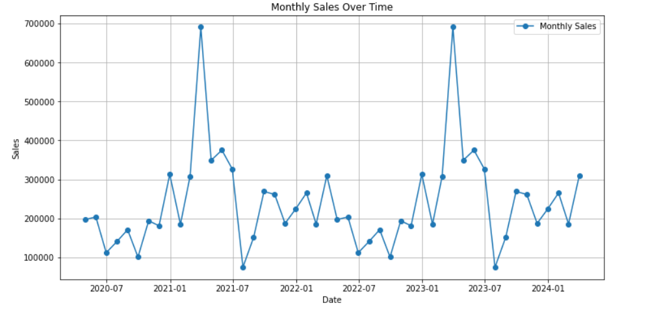

* **Forecast**:
  + Forecasted sales for the next 12 months indicate moderate growth with seasonal dips.
  + Visualization:

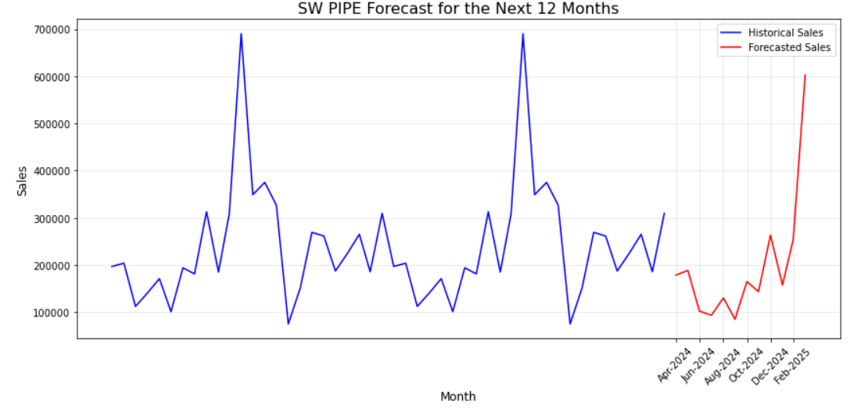

* + **Forecast values** : Forecasted Sales Table

| **DATE** | **FORECASTED SALES** |
| --- | --- |
| 2024-04-30 | 178541.008659 |
| 2024-05-31 | 188552.316204 |
| 2024-06-31 | 102283.532965 |
| 2024-07-30 | 93375.599487 |
| 2024-08-31 | 130123.690611 |
| 2024-09-30 | 84840.735819 |
| 2024-10-31 | 164782.978621 |
| 2024-11-30 | 143607.280197 |
| 2024-12-31 | 263395.213258 |
| 2025-1-31 | 157468.351772 |
| 2025-2-30 | 254129.279772 |
| 2025-3-31 | 603064.463117 |

#### **Material 2: RCC PIPES**

* **Historical Trends**:
  + Sales data from January 2020 to April 2024 shows increasing and decreasing trends overtime with notable seasonal fluctuations .
  + Visualization:

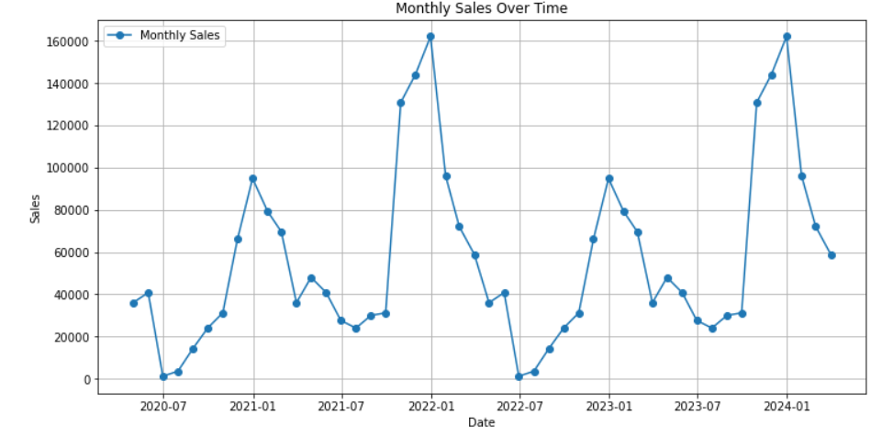

* **Forecast**:
  + Forecasted sales for the next 12 months indicate moderate growth with seasonal dips.
  + Visualization:

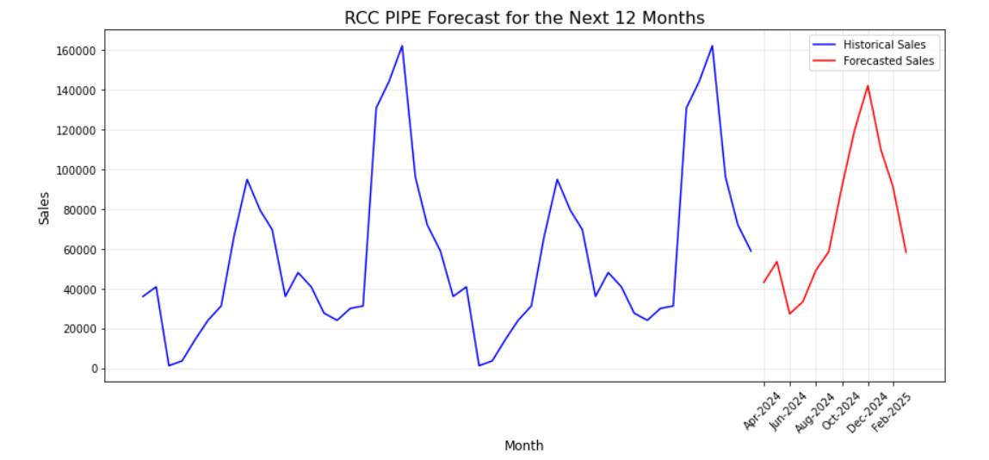

* + **Forecast values** : Forecasted Sales Table

| **DATE** | **FORECASTED SALES** |
| --- | --- |
| 2024-04-30 | 43057.950823 |
| 2024-05-31 | 53468.009301 |
| 2024-06-31 | 27229.684904 |
| 2024-07-30 | 33319.209656 |
| 2024-08-31 | 49213.630876 |
| 2024-09-30 | 58504.580221 |
| 2024-10-31 | 91206.562670 |
| 2024-11-30 | 119732.292111 |
| 2024-12-31 | 141957.347902 |
| 2025-1-31 | 109568.029868 |
| 2025-2-30 | 91260.399666 |
| 2025-3-31 | 58213.791687 |

#### **Material 3: RCC COVERS**

* **Historical Trends**:
  + Sales data from January 2020 to April 2024 shows increasing and decreasing trends overtime with notable seasonal fluctuations .
  + Visualization:

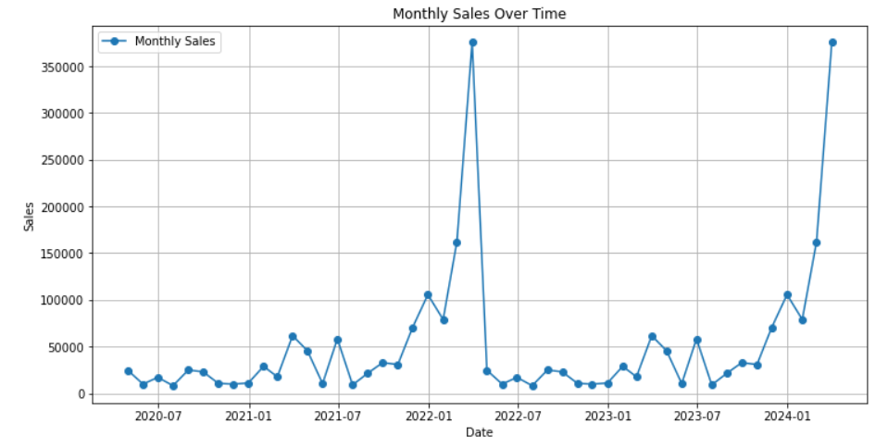

* **Forecast**:
  + Forecasted sales for the next 12 months indicate moderate growth with seasonal dips.
  + Visualization:

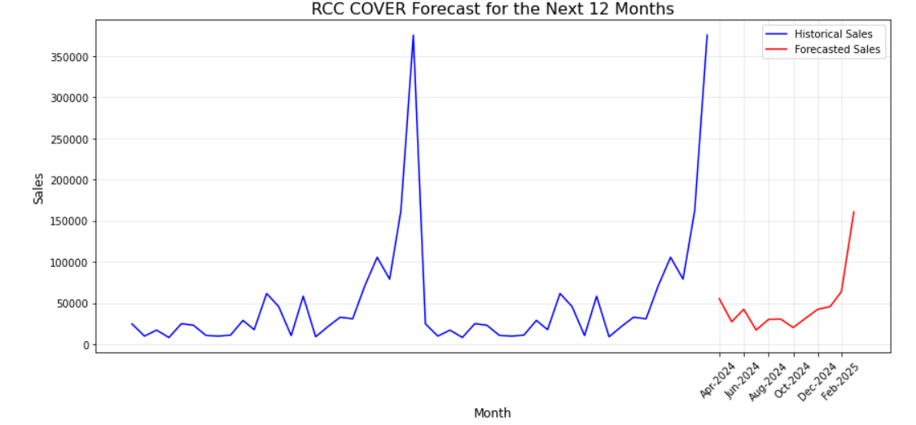

* + **Forecast values** : Forecasted Sales Table

| **DATE** | **FORECASTED SALES** |
| --- | --- |
| 2024-04-30 | 55331.968637 |
| 2024-05-31 | 27198.023954 |
| 2024-06-31 | 42325.161510 |
| 2024-07-30 | 17171.446283 |
| 2024-08-31 | 30116.107123 |
| 2024-09-30 | 30494.309534 |
| 2024-10-31 | 20150.507909 |
| 2024-11-30 | 31150.393311 |
| 2024-12-31 | 42249.635924 |
| 2025-1-31 | 45646.517700 |
| 2025-2-30 | 63764.014285 |
| 2025-3-31 | 160673.366026 |

#### **Material 4: CI COVERS F&C**

* **Historical Trends**:
  + Sales data from January 2020 to April 2024 shows increasing and decreasing trends overtime with notable seasonal fluctuations
  + Visualization:

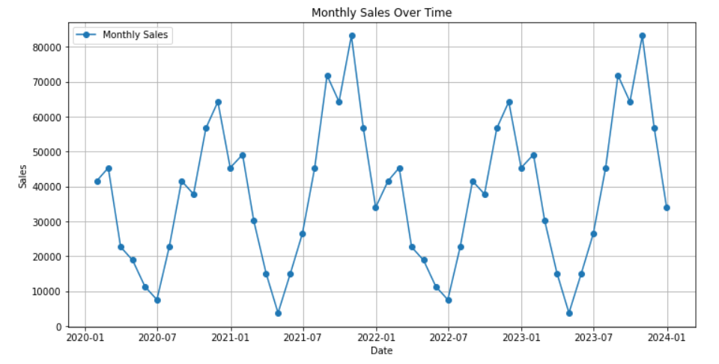

* **Forecast**:
  + Forecasted sales for the next 12 months indicate moderate growth with seasonal dips.
  + Visualization:

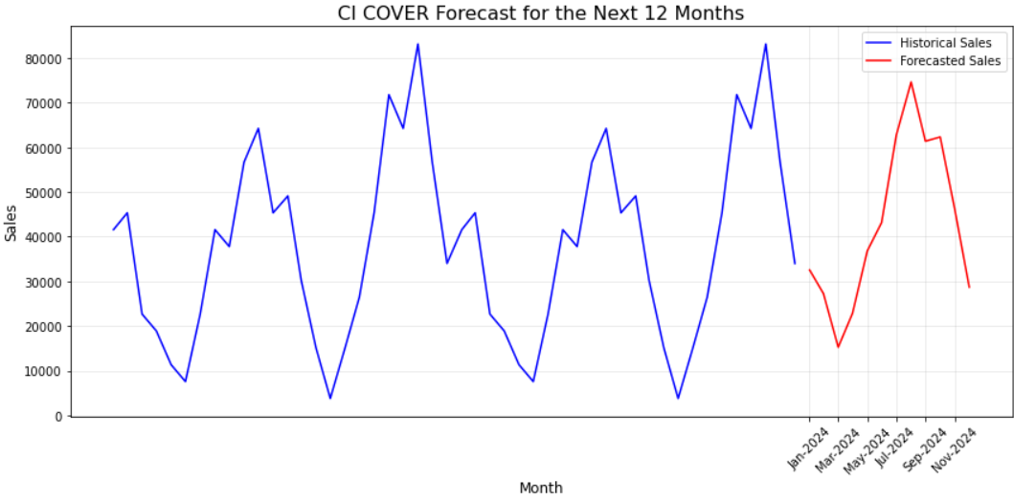

* + **Forecast values** : Forecasted Sales Table

| **DATE** | **FORECASTED SALES** |
| --- | --- |
| 2024-04-30 | 32548.190719 |
| 2024-05-31 | 27261.739484 |
| 2024-06-31 | 15262.508568 |
| 2024-07-30 | 22850.850085 |
| 2024-08-31 | 36824.456885 |
| 2024-09-30 | 43167.241736 |
| 2024-10-31 | 62792.892371 |
| 2024-11-30 | 74654.996112 |
| 2024-12-31 | 61391.660051 |
| 2025-1-31 | 62342.946720 |
| 2025-2-30 | 46444.223342 |
| 2025-3-31 | 28708.058772 |

### **Recommendations:**

1. **Strategic Inventory Management**:
   * Based on the forecasted sales trends, the company should ensure optimal inventory levels for each material to avoid understocking or overstocking.
   * Seasonal trends should guide inventory adjustments, particularly for materials showing significant seasonality.
2. **Focus on High-Demand Periods**:
   * Increase production and marketing efforts during high-demand months identified in the forecasts.
   * Plan promotions or discounts during periods of forecasted lower sales to maintain consistent revenue.

### **Limitations:**

1. **Data Limitations**:
   * Forecasts are highly dependent on the quality and quantity of historical data. Any inaccuracies or missing data may affect predictions.
   * The dataset length (48 months) may limit the ability to fully capture long-term patterns or unusual trends.
2. **Assumptions of Stationarity**:
   * The SARIMA model assumes stationarity after differencing. If the data contains structural breaks or other non-stationary components, the model may not fully capture them.
3. **External Factors Not Included**:
   * Factors like economic conditions, competitor actions, or policy changes are not accounted for in the forecast, which may impact actual sales.
4. **Model Specificity**:
   * The SARIMA model is tailored for time series data with seasonality. It may not perform well if the data has non-linear patterns or irregular seasonality.

### **Conclusion:**

* This project demonstrates the value of time series forecasting in providing a comprehensive understanding of sales trends and patterns for the company’s materials. By leveraging historical data and advanced forecasting techniques, the analysis has uncovered key insights into seasonal trends, potential growth opportunities, and areas of concern.
* The time series analysis and forecasting for the four materials provide actionable insights into sales trends, seasonality, and expected future performance. While the forecasts indicate periods of growth and potential challenges, the recommendations aim to help the company optimize operations and improve strategic decision-making.

**Link:**

MATRIX CORP. - [**https://akcorporation.co/**](https://akcorporation.co/)